Name: VEN THON

Id: e20191250

Group: I5-GIC-C

+Docker ps

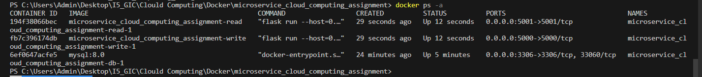

+ postman testing on API endpoints: both read and write service

